Chapter 9, Solution 52.

If V_{o} = 8∠30° V in the circuit of Fig. 9.59, find I_{s}.

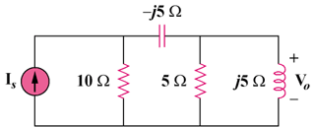

Figure 9.59
For Prob. 9.52.

Solution

We begin by simplifying the circuit. First, we replace the parallel inductor and resistor with their series equivalent.

Next let , and .

Z₂

Z₁

I₂

I_{S}

By current division .

Since we can now find I_{s}.

2.884–26.31 A.

